YARD Newsletter
Volume 1, Issue 6 May 2017

Recital 2017
Magic & Mystery
This year’s recital will be held on Saturday, June 10th, 2017 beginning at 6:30 at the Spring Grove Area Middle School located on Old Hanover Road in Spring Grove. Ticket prices are Adult - $15.00, Student - $10.00, ages 2 and under are free. Tickets are required for all admissions to the recital. Doors will open at 6:00 pm. We will have reserved seating again this year. Tickets go on sale April 24th, 2017. The Dazzling Gems Dance Company will be having refreshments and flowers for sale in the lobby.

Dress rehearsal will be held during the day of the 10th. Recital line-up is attached. If you are in Act 1 rehearsal is 9:00 – 11:30 with the finale first. Act 2 rehearsal is 12:30 – 3:00 with the finale first. Doors open at 8:00 a.m. with warm-up at 8:30 – 9:00. If you are in both acts lunch will be 11:30 – 12:30.

The costume book is now located in the studio lobby. It lists all the costume accessories, tights, shoes and hair styles required of each dancer for the dress rehearsal and the recital. If you have any questions, please contact your student’s dance instructor.

Important Dates to Remember

- Tuition due the 7th of each month
- May 13th, 2017 – Studio Pictures – Mark your calendar
- Thursday, May 18th, 2017 – Studio Closed
- May 29th, 2017 – Memorial Day – Studio Closed
- June 10th, 2017 – Recital
- Summer Classes start July 10th – August 17th

Like the YARD on Facebook to receive updates on events and happening!

Follow us on Instagram!

Class Photos

Attached is a class photo schedule for Saturday, May 13th, 2017. Studio will open at 8:00 a.m. Please have your dancer ready ½ hour before block time. Please let the office know if you cannot attend!

All students are to be in full costume which includes the required tights, shoes, hair and make – up. Please refer to the costume book in the lobby for details. Full make-up consists of foundation, eyeliner, mascara, earth tone eye shadows and RED lipstick. If you go out to our Facebook page you can see a tutorial.

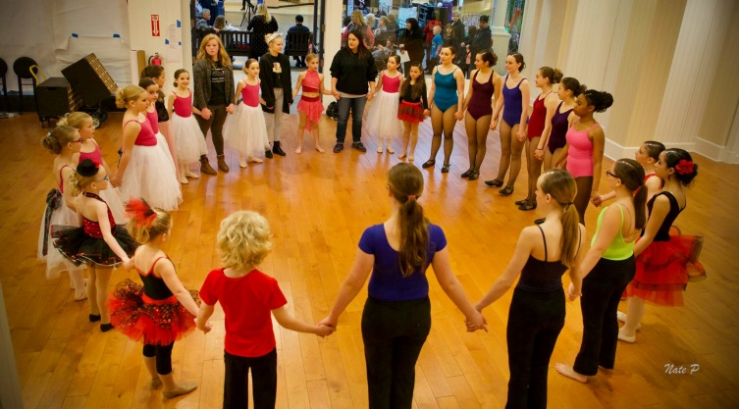
Studio will be closed on Thursday, May 18th, 2017. Dazzling Gems Dance Company will be attending the Talent Olympics Dance Competition in the Poconos.

YARD will have a special guest at this year’s recital – “Magic & Mystery”. Eddy Ray has performed magic shows all over the world from Las Vegas, Nevada to the Far East, Tokyo, Japan. His shows are not your stereotypical magic shows; there is no cheesy 70’s music, no tops hats or horrid looking costumes. Eddy Ray has a refreshing modern, versatile and cutting edge approach to his magical performances.

If you are interested in placing an Advertisement in our Recital 2017 brochure please fill out the paper attached. If you sell 2 ads you will get 1 free recital ticket!

Also attached is a Personal Message form for the program. Please submit all messages to the studio office no later than May 12th, 2017.

DVD’s for the recital are available to order at a cost of $25.00, order forms are attached. You will need to pay for the DVD with a check made payable to Bob’s video. DVD’s may be ordered up until June 26th, 2017 at the regular price. After that, the cost will be $30.00.

Recital T-shirt information will be out sometime in May.

Perfect Attendance cut off will be April 27th, 2017. If you need to know if you have classes to make-up please see someone in the office. All Perfect Attendance students receive a certificate and recognition at our annual recital. Make up those classes before it’s too late!!

Ballet Parent Tidbits:
Please take your child’s tutu out of the bag and leave it hanging upside down. Do not put it back in the bag until recital is over. If it is wrinkled, hang it in the bathroom during someone’s shower and the steam will help straighten it out. This will help the tutu lay correctly on your daughter. Please ask your child’s teacher if you have any questions.

Dazzling Gems Dance Company
Did you know the studio has a pre-professional performing group? The Dazzling Gems Dance Company is open to any student taking at least one class at the studio. Practices are held on Friday nights and/or Saturday Mornings. The Company dancers perform at local events as well as attend dance competitions and workshops throughout the year. If you are interested in finding out more about Company, please contact Jen Cooper, DGDC Board President at barrelmakers@comcast.net

Dazzling Gems Dance Company will be attending the Talent Olympics Dance Competition Thursday, May 18th – Sunday, May 21st in the Poconos.

Come see Dazzling Gems Dance Company perform at the Galleria Mall on Sunday, May 13th, 2017 from 1-4.

amazonsmile
Please support the Dazzling Gems Dance Company simply by shopping on Amazon. All you have to do is use the link below when you shop, and a percentage of your purchase price will go to DGDC. Your support will allow the dancers to perform at community events and competitions.

You can also bookmark that link, so you can contribute to DGDC every time you shop. It’s easy and won’t cost you any additional money.

https://smile.amazon.com/ch/45-4011047

Thank you for your support!

