YARD Newsletter
Volume 1, Issue 3 February 2019

Important Dates to Remember

- Tuition due the 7th of each month
- April 17 – April 22, 2019 – Easter/Spring Break – Studio Closed
- April 29, April 30, May 1 and May 2, 2019 – Parent Observation Week
- May 11, 2019 – Studio Pictures – Mark your calendar
- May 27, 2019 – Memorial Day – Studio Closed
- June 8, 2019 - Recital

Like the YARD on Facebook to receive updates on events and happening!

Follow us on Instagram!

Recital 2019
“Dancing through the 80’s”

YARD Recital will be held Saturday, June 8th, 2019 at Spring Grove Middle School. Details about ticket prices, time, messages, etc. will be available in March’s newsletter. Costumes and songs have been chosen for Recital. The costume book will be out at the end of February that will include tights, shoes, hair information, etc.

Dressing Room help for Recital 2019!
We will be looking for a few moms that would
like to help in the dressing rooms this year.
If you have your volunteer clearances with
the State of PA and you would like to help.
Please see Kim in the office.

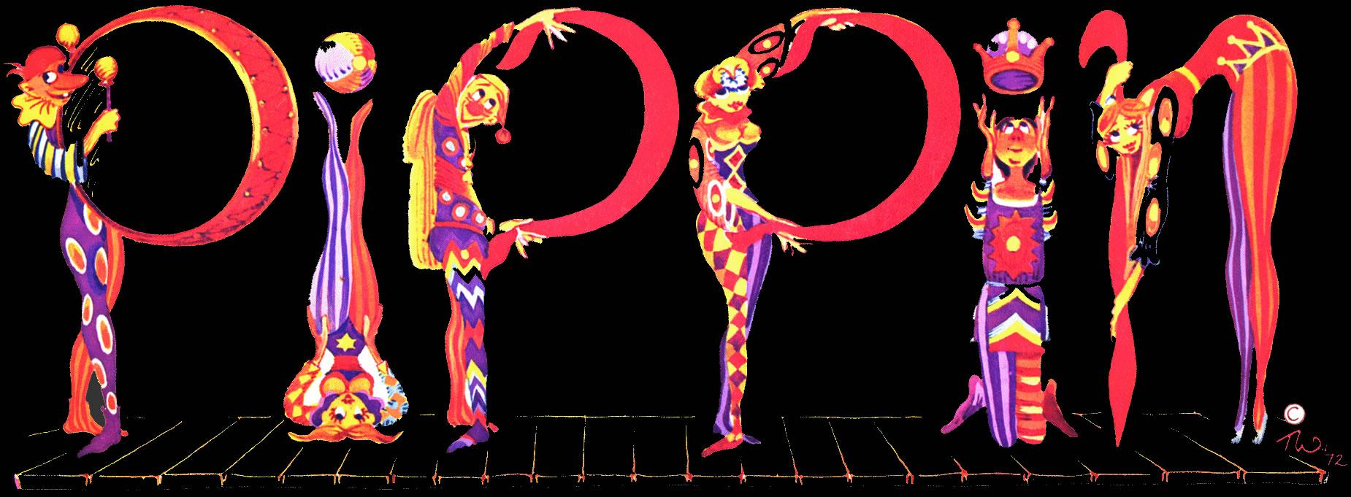

This year’s Spring Grove Musical is “Pippin”; it will be performed Friday March 1, Saturday March 2 and Sunday March 3. Miss Charlee is choreographing the musical again this year. She will be missing some of her classes but assures you the best substitutes will be teaching for her. Several YARD students will also be in the production - Miranda Arnold, Lindsay Curley, Morgan Myers, Bailey Phillips, Delaney Pittman, Ava Plummer, Edie Rumbaugh and Jessica Schmuck. Good Luck Miss Charlee and students!!

This year’s West York Musical is “Bye Bye Birdie”; it will be performed Saturday March 22 at 7:00 pm and Sunday, March 23, 2019 at 2:00 in the WYAHS auditorium. Sydney Cooper from the YARD will be in this production.

Studio Closings and Make Up Policy
Whenever inclement weather strikes, the Studio, will generally follow the same schedule as the Spring Grove School District – if the district closes and/or cancels evening activities, we will close as well. We will post all closings no later than 3:00 pm on the studio answering machine, WGAL8and on the YARD’s Facebook page.

If your child is sick or misses class due to other activities, your child may make up the missed class(es) in any level equal to or lesser than his/her current level. All made up classes will count towards perfect attendance. Studio closings due to weather related issues do not count against your child’s attendance but can be made up if you choose.

If you would like to know how many class your dancer needs to make up, stop by the office and attendance is available through Dec 31, 2018. All classes will need to be made up by May 3, 2019.

Proper Class Attire
Just a reminder that the Studio has a “no junk” dress policy. This means no tanks, tee or sweats in class. Ballet students must have:
- Solid color leotard
- Pink footed tights
- Ballet shoes
- Hair put back in a nice, clean bun

Dazzling Gems Dance Company
Did you know the studio has a pre-professional performing group? The Dazzling Gems Dance Company is open to any student taking at least one class at the studio. Practices are held on Friday nights and/or Saturday Mornings. The Company dancers perform at local events as well as attend dance competitions and workshops throughout the year. If you are interested in finding out more about Company, please contact Jen Cooper, DGDC Board President at barrelmakers@comcast.net

SMILE!
PICTURE DAY!!!

Saturday,
May 11, 2019
Please mark your calendar!
Schedule will come out closer to May

NOTE: Photography will be by
Showstopper Photography.
Check them out at
http://www.showstopperphotography.com/
SMILE!!!

